Fundamentals Of Data Science
CSA-0412
Name : B.Ganga Niranjan
Reg No : 192424041
Date : 08-01-2026

6. Grocery Store – Calculate Total Cost (Discount + Tax)
Code:
prices = [10, 5, 8]
quantities = [2, 3, 1]
discount_rate = 10
tax_rate = 5
subtotal = sum(price * qty for price, qty in zip(prices, quantities))
discount_amount = subtotal * (discount_rate / 100)
discounted_total = subtotal - discount_amount
tax_amount = discounted_total * (tax_rate / 100)
total_cost = discounted_total + tax_amount
print("Subtotal:", subtotal)
print("Discounted Total:", discounted_total)
print("Final Total Cost:", total_cost)
Output:
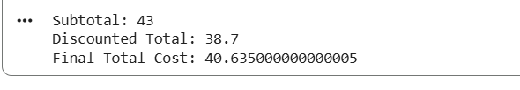

7. E-commerce Orders Analysis (Pandas)

Code:
import pandas as pd
order_data = pd.DataFrame({
"customer_id": [1, 1, 2, 3, 2],
"order_date": pd.to_datetime(["2023-01-01", "2023-01-05", "2023-01-03", "2023-01-07", "2023-01-10"]),
"product_name": ["Laptop", "Mouse", "Laptop", "Keyboard", "Mouse"],
"order_quantity": [1, 2, 1, 1, 3]
})
orders_per_customer = order_data.groupby("customer_id").size()
print(orders_per_customer)
avg_quantity = order_data.groupby("product_name")["order_quantity"].mean()
print(avg_quantity)
earliest_date = order_data["order_date"].min()
latest_date = order_data["order_date"].max()
print("Earliest:", earliest_date)
print("Latest:", latest_date)
Output:
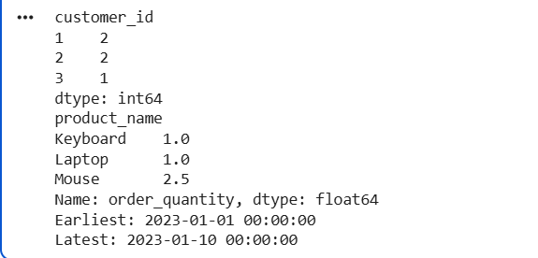
8. Top 5 Best-Selling Products (Past Month)
Code:
top_products = (
order_data.groupby("product_name")["order_quantity"]
.sum()
.sort_values(ascending=False)
.head(5)
)
print(top_products)
Output:
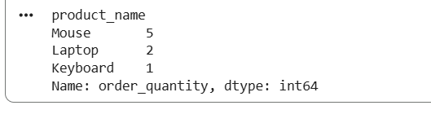

9. Real Estate Property Analysis
Code:
property_data = pd.DataFrame({
"property_id": [101, 102, 103, 104],
"location": ["NY", "LA", "NY", "LA"],
"bedrooms": [3, 5, 4, 6],
"area_sqft": [1500, 2500, 1800, 3000],
"listing_price": [500000, 750000, 600000, 900000]
})
avg_price = property_data.groupby("location")["listing_price"].mean()
print(avg_price)
count_large = property_data[property_data["bedrooms"] > 4].shape[0]
print("Properties with >4 bedrooms:", count_large)
largest_property = property_data.loc[property_data["area_sqft"].idxmax()]
print(largest_property)

Output:
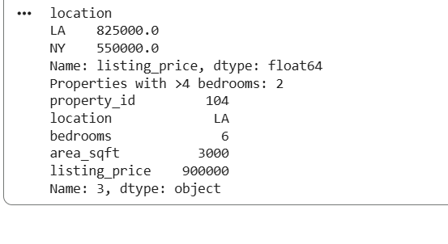

10. Data Visualization with Matplotlib
Code:
import matplotlib.pyplot as plt
months = ["Jan", "Feb", "Mar", "Apr", "May"]
sales = [2000, 2500, 3000, 2800, 3500]
plt.plot(months, sales, marker='o')
plt.title("Monthly Sales - Line Plot")
plt.xlabel("Month")
plt.ylabel("Sales")
plt.grid(True)
plt.show()
plt.bar(months, sales)
plt.title("Monthly Sales - Bar Plot")
plt.xlabel("Month")
plt.ylabel("Sales")
plt.show()

Output:
